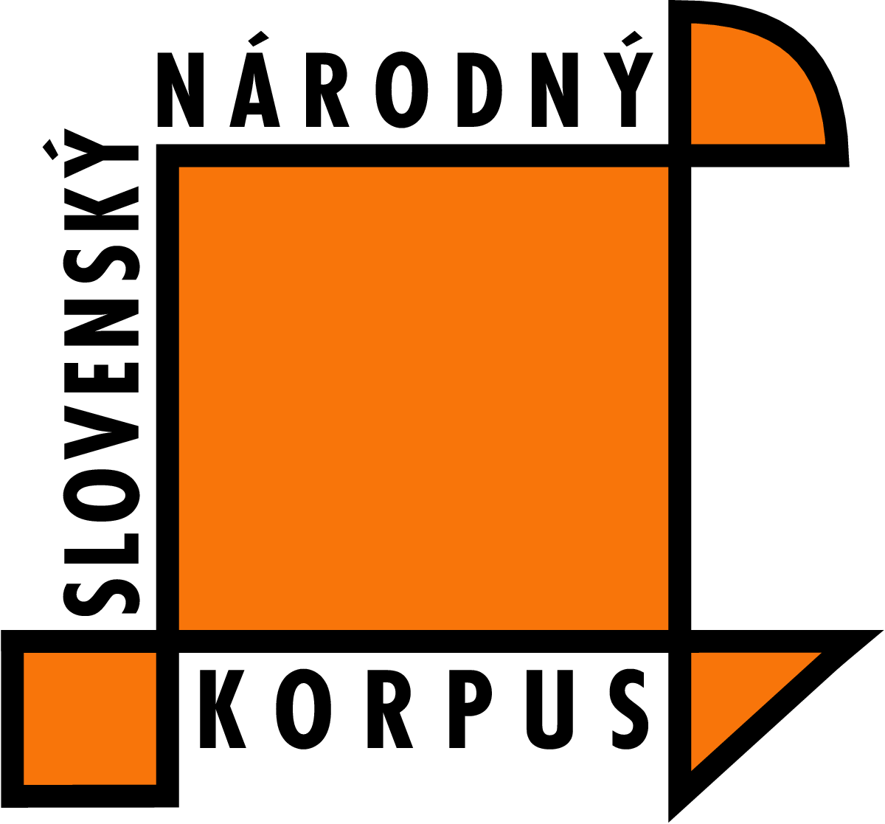

SLOVAK NATIONAL CORPUS
Ľ. ŠTÚR INSTITUTE OF LINGUISTICS

The Fourth International Seminar

SLOVKO 2007

NLP, Computational Lexicography and Terminology

25 – 27 October 2007, Bratislava
Inštitút pre verejnú správu, M. Schneidra-Trnavského 1, Bratislava

PROGRAMME
25 October 2007, THURSDAY
8:00 – 9:15 REGISTRATION

9:30 – 9:40 Opening Speech

Session Chair František Čermák
9:40 – 10:00 Mercè Vázquez and Luis Villarejo, Open University of Catalonia, Spain
Lexterm, an Open Source Tool for Lexical Extraction
10:00 – 10:20 Dariusz Piechociński and Dominika Urbańska, Poland
Automatic Term Recognition in Polish Texts
10:20 – 10:40 Oksana Kozak, Kyiv National Linguistic University, Ukraine
The Role of Word Frequency Vocabularies in the Research of Psychology and Philosophy Terminological Systems

10:40 – 11:00 COFFEE BREAK

Session Chair Milan Rusko
11:00 – 11:20 Michal Křen, Institute of the Czech National Corpus, Charles University, Prague, Czech Republic
Variation of Czech Lexicon as Reflected by Corpora Comparison
11:20 – 11:40 Marek Grác, Faculty of Informatics, Masaryk University, Brno, Czech Republic
Effective Methods of Building Slovak-Czech Dictionary
11:40 – 12:00 Aleš Horák and Adam Rambousek, Faculty of Informatics, Masaryk University, Brno, Czech Republic
Administration Framework for the DEB Dictionary Server

12:00 – 14:00 LUNCH

Session Chair Adam Przepiórkowski
14:00 – 14:20 Michal Laclavík, Institute of Informatics, Slovak Academy of Sciences, Bratislava, Slovakia
Marek Ciglan, Martin Šeleng, Stanislav Krajčí, Peter Vojtek, Ladislav Hluchý
Semi-automatic Semantic Annotation of Slovak Texts
14:20 – 14:40 Dana Hlaváčková and Karel Pala, Faculty of Informatics, Masaryk University, Brno, Czech Republic
Computer Processing Derivational Relations in Czech
14:40 – 15:00 Tatiana Bobkova, Kyiv National Linguistic University, Ukraine
Systemic and Functional Features of the Category of Number of Ukrainian, Russian and English Nouns

15:00 – 15:20 COFFEE BREAK

Session Chair Jan Hajič
15:20 – 15:40 Renata Blatná, Institute of the Czech National Corpus, Charles University, Prague, Czech Republic
On Valency of Some Czech Verbs with Multi-Word Prepositions (Based on the Czech National Corpus) (CZE)
15:40 – 16:00 Radovan Garabík, Slovak National Corpus, Ľ. Štúr Institute of Linguistics, Slovak Academy of Sciences, Bratislava, Slovakia
Marína Mikulajová, Faculty of Education, Comenius University, Bratislava, Slovakia
A Cross-linguistic Database of Children's Printed Words in Three Slavic Languages

16:10 – 17:10 Karel Pala, Faculty of Informatics, Masaryk University, Brno, Czech Republic
Lexicographical Software Tools (UND)

26 October 2007, FRIDAY
Session Chair Klára Buzássyová
9:00 – 9:20 Albena Rangelova and Jan Králík, Institute of the Czech Language, Academy of Sciences, Prague, Czech Republic
Wider Framework of the Research Plan Creation of a Lexical Database of the Czech Language of the Beginning of the 21st Century (CZE)
9:20 – 9:40 Jindra Světlá, Institute of the Czech Language, Academy of Sciences, Prague, Czech Republic
The Possibilities and Limits of Lexicographical Description of the Czech Lexicon in Database Form (CZE)
9:40 – 10:00 Milada Voborská, Institute of the Czech Language, Academy of Sciences, Prague, Czech Republic
Tools for the Input of Morphological Data – L 21 Solution Proposal (CZE)
10:00 – 10:20 Zdeňka Opavská and Barbora Štěpánková, Institute of the Czech Language, Academy of Sciences, Prague, Czech Republic
Tools for Working with Corpus Evidence in the Lexical Database LEXIKON 21 (Program PRAMAT and the Exemplification Tool) (CZE)
10:20 – 10:40 Věra Chudomelová and Edith Birkhahnová, Institute of the Czech Language, Academy of Sciences, Prague, Czech Republic
The Possibilities of Lexicographic Description of Terms in the Lexical Database LEXIKON 21 (CZE)
10:40 – 11:00 COFFEE BREAK

Session Chair Viktor Zakharov
11:00 – 11:20 František Čermák, Institute of the Czech National Corpus, Charles University, Prague, Czech Republic
Úzus a syntax interjekcí: případ češtiny (CZE)
11:20 – 11:40 Mária Šimková, Slovak National Corpus, Ľ. Štúr Institute of Linguistics, Slovak Academy of Sciences, Bratislava, Slovakia
Partikuly a interjekcie v slovníkových výkladoch (SLK)
11:40 – 12:00 Elizaveta Rumyantseva, Moscow State Linguistic University, Russia
Optimization of Russian Bilingual Dictionaries (RUS)
12:00 – 14:00 LUNCH
Session Chair Karel Pala
14:00 – 14:20 Natalia Darchuk, Liudmila Aleksienko, Viktor Sorokin, Kyiv National Linguistic University, Ukraine
The Text Corpus and Dictionary Hierarchy (UKR)
14:20 – 14:40 Viktor Zakharov, Faculty of Philology, St.Petersburg State University, Russia
Citation Card Files, Corpora of the Past (SLA)
14:40 – 15:00 Róbert Sabo, Institute of Informatics, Slovak Academy of Sciences, Bratislava, Slovakia
The Phonological Model of Slovak Prosody (SLK)
15:00 – 15:20 Martina Waclawičová, Institute of the Czech National Corpus, Charles University, Prague, Czech Republic
Spoken Corpus ORAL 2006, Information that it Provides and General
Characteristics of Spoken Text
15:20 – 15:40 Radovan Garabík, Slovak National Corpus, Ľ. Štúr Institute of Linguistics, Slovak Academy of Sciences, Bratislava, Slovakia
Milan Rusko, Institute of Informatics, Slovak Academy of Sciences, Bratislava, Slovakia
Towards a Speech Corpus of Slovak Language
15:40 – 16:00 COFFEE BREAK
Session Chair Aleš Horák
16:00 – 16:20 Jozef Ivanecký, European Media Laboratory GmbH, Heidelberg, Germany
Daniela Majchráková
Slovak National Corpus, Ľ. Štúr Institute of Linguistics, Slovak Academy of Sciences, Bratislava, Slovakia
Statistical Syllable Segmentation Precision as a Function of Training Data Quality
16:20 – 16:40 Adam Przepiórkowski, Institute of Computer Science, Polish Academy of Sciences, Poland
Automatic Valence Acquisition in Polish
16:40 – 17:00 Peter Ďurčo, University of St. Cyril and Methodius, Trnava, Slovakia
Collocations in Slovak (Based on the Slovak National Corpus) (SLK)
19:00 SOCIAL EVENT (Bratislava City Centre, Biela ulica № 3)

27 October 2007, SATURDAY
Session Chair Radovan Garabík
9:00 – 9:20 Maria Khokhlova, Faculty of Philology, St. Petersburg State University, Russia
Collocations in Russian: Analysis of Association Measures
9:20 – 9:40 Olga Mitrofanova, Faculty of Philology, St. Petersburg State University, Russia
Viktoria Belik, Vera Kadina
Corpus Analysis of Selectional Preferences in Russian
9:40 – 10:00 Olga Mitrofanova, Faculty of Philology, St. Petersburg State University, Russia
Polina Panicheva, Vyacheslav Savitsky
Automatic Word Clustering in Russian Texts Based on Latent Semantic Analysis
10:00 – 10:20 COFFEE BREAK
Session Chair Jozef Ivanecký
10:20 – 10:40 Dorota Vasilišinová and Radovan Garabík, Slovak National Corpus, Ľ. Štúr Institute of Linguistics, Slovak Academy of Sciences, Bratislava, Slovakia
Parallel French-Slovak Corpus
10:40 – 11:00 Peter Vojtek and Mária Bieliková, Faculty of Informatics and Information Technologies,
Slovak University of Technology, Bratislava, Slovakia
Comparing Natural Language Identification Methods Based on Markov Processes
11:00 – 11:20 Karel Kučera, Institute of the Czech National Corpus, Charles University, Prague, Czech Republic
Hyperlemma: a Concept Emerging from Lemmatizing Diachronic Corpora
11:20 – 11:40 Jana Levická, Slovak National Corpus, Ľ. Štúr Institute of Linguistics, Slovak Academy of Sciences, Bratislava, Slovakia
Building Slovak Terminology Database: Definition and Defining Context Evaluation

11:20 Conclusion

12:00 LUNCH

Language of the presentation is indicated in ISO 639-3 code in brackets next to the presentation title. If omitted, the presentation will be in English.

